GLOBAL SALES AND FINANCIAL PERFORMANCE
DASHBOARD

Using Microsoft Power BI

Project Report

Submitted By
Name: Samyuktha.AR
Roll No.: E25FA066
Tool Used: Microsoft Power BI Desktop

1. INTRODUCTION
This project focuses on the development of a Global Sales and Financial Performance Dashboard using Microsoft Power BI. The dashboard converts sales transaction data into meaningful business information through the use of KPI cards, charts, tables, slicers and interactive visuals.
The report analyses important business measures such as sales, cost, profit and quantity. The data is further examined based on different dimensions including product categories, months, geographical regions and employees. The interactive nature of the dashboard allows users to explore the data and understand business performance from different perspectives.
2. OBJECTIVES
The major objectives of developing the Power BI dashboard are:
- To analyse the overall business performance using total sales, total cost, total profit and total quantity.
- To create an interactive sales and financial performance dashboard using Microsoft Power BI.
- To compare sales performance among different product categories.
- To examine sales trends across different months and regions.
- To identify employees who contribute comparatively higher levels of profit.
- To provide product-level information relating to sales, profit and quantity.
- To enable users to filter and analyse the report based on year, product category and region.
- To present complex sales information in a simple and understandable visual format.
3. DATASET DESCRIPTION
The dashboard has been developed using a dimensional Power BI data model. The model consists of various dimension tables and a fact table that together support detailed sales analysis.
The major tables included in the model are:
- DimCustomer – contains customer-related information.
- DimDate – provides date and time information for analysing sales over different periods.
- DimEmployee – contains employee-related information.
- DimGeography – provides geographical and regional details.
- DimProduct – contains information about products and their categories.
- FactSales – contains the actual sales transaction information.
These tables work together to provide a structured basis for analysing sales performance.
The main business indicators included in the dashboard are:
- Total Sales
- Total Cost
- Total Profit
- Total Quantity
- Order Count
- Average Sales
4. DATA PREPARATION
Before creating the dashboard, the dataset was prepared and organised in Microsoft Power BI Desktop.
The major data preparation activities included:
- Importing the sales data model into Power BI Desktop.
- Checking and cleaning the available data.
- Using product, date, employee and geography dimensions for analysis.
- Establishing the required data relationships between the tables.
- Preparing the required DAX measures for business calculations.
- Creating KPI cards for displaying important performance indicators.
- Designing charts and tables for analysing different aspects of the data.
- Adding slicers to make the dashboard interactive and user-friendly.
The prepared data model was then used to build the final dashboard.

5. DAX MEASURES USED
DAX (Data Analysis Expressions) was used in Power BI to create measures for calculating important business indicators. These measures were used in KPI cards, tables and different analytical visuals.
Measure / Indicator | Purpose
Total Sales | Calculates the overall sales value generated from the sales transactions.
Total Cost | Determines the total cost associated with the sales.
Total Profit | Calculates the profit generated from the sales after considering the relevant cost.
Total Quantity | Represents the total quantity of products sold.
Order Count | Counts the orders or sales records available in the dataset.
Average Sales | Calculates the average sales value represented in the dataset.

Dax validation
The DAX measures were validated in Power BI by checking the formulas for syntax errors and confirming that the calculated values were displayed correctly in the relevant visuals. The measures were also tested using tables, KPI cards and slicers to ensure that the results changed appropriately when filters were applied.
This validation helped ensure that the calculations used in the dashboard were functioning correctly.
6. DASHBOARD COMPONENTS
The Power BI report consists of several components, including KPI cards, tables, charts, slicers, DAX measures, visualisations and sales tooltips. Each component provides a different level of information about the business performance.
A. KPI Cards
The dashboard uses KPI cards to display the major business indicators at a glance.
The key values displayed are:
- Total Sales: 70.64M
- Total Cost: 45.52M
- Total Profit: 25.12M
- Total Quantity: 300K
- Average Sales: 706.36
These KPI cards provide a quick summary of the overall financial and sales position before users examine the detailed visualisations.
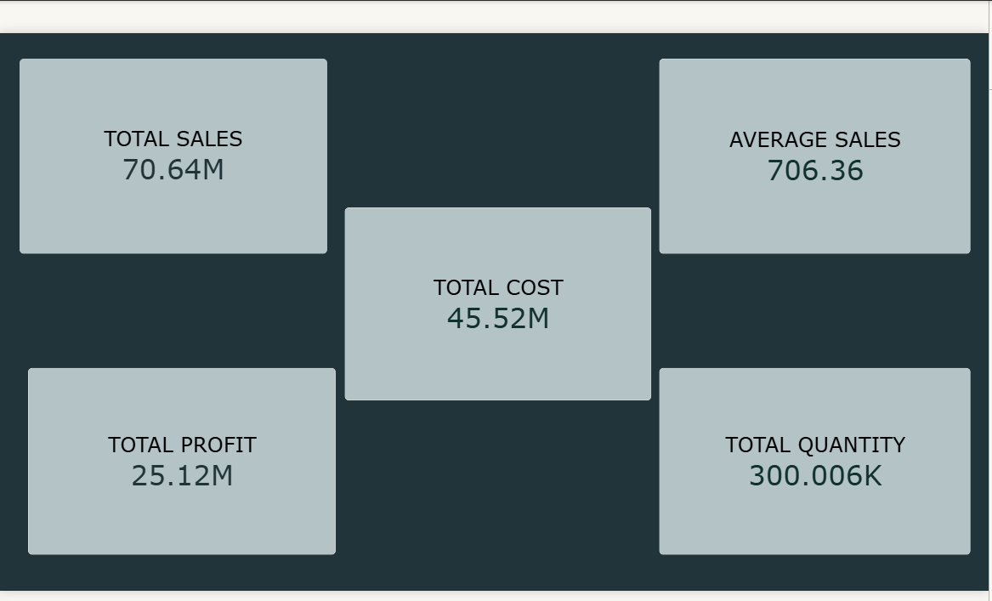
B. PRODUCT-LEVEL TABLE
The product table provides detailed information for individual products.
The table contains:
- Product Name
- Total Quantity
- Total Profit
- Total Sales
The dashboard records approximately 70.64M in total sales and approximately 25.12M in total profit. The table makes it possible to compare individual products based on their sales, profit and quantity.
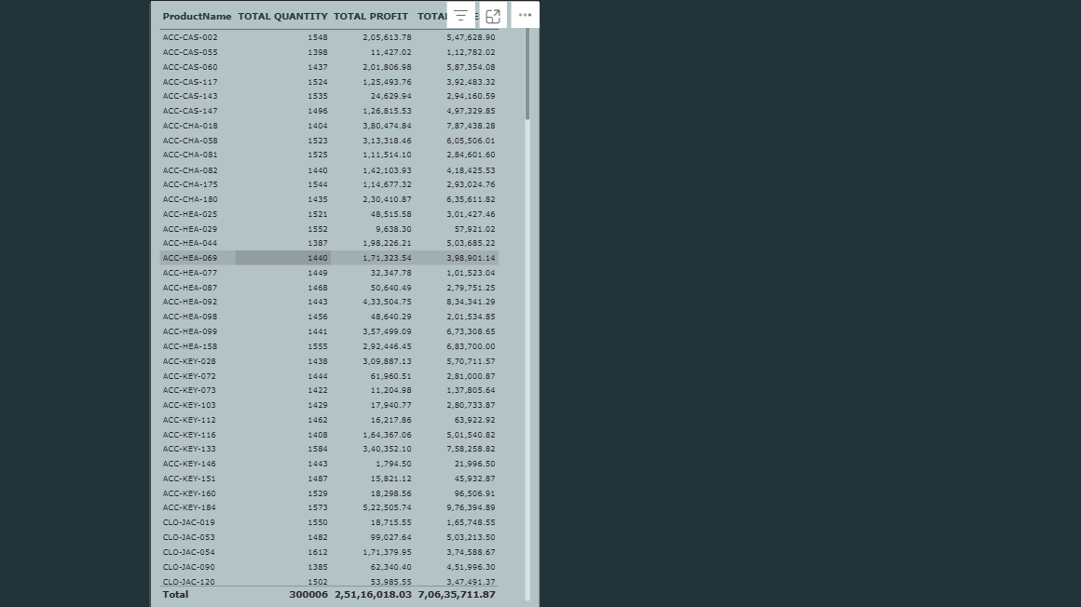
7. VISUALISATIONS
The dashboard contains different visualisations to represent the sales and financial information in an easy-to-understand manner.
A. TOTAL SALES BY CATEGORY
A column chart is used to compare sales among six different product categories:
- Clothing
- Accessories
- Kitchen
- Electronics
- Outdoors
- Furniture
Based on the displayed chart, Clothing has the highest sales contribution, while Outdoors and Furniture are among the categories with comparatively lower sales.
This visual helps in understanding how different product categories contribute to overall sales.

B. MONTHLY TOTAL SALES
A line chart is used to analyse sales performance across different months.
The displayed sales values fluctuate approximately between 5.6M and 6.2M. The chart helps identify variations in monthly sales and provides a clear view of the overall sales pattern over time.

C. TOTAL PROFIT BY EMPLOYEE
A horizontal bar chart is used to compare the profit contribution of different employees.
The visual helps management identify employees who are generating comparatively higher levels of profit. It also allows employee-wise performance to be compared within the selected filters.

D. TOTAL SALES BY REGION
A donut chart is used to display the distribution of sales among the different regions:
- Central
- South
- West
- North
- East
The regional distribution shown in the dashboard is relatively balanced, with each region contributing approximately one-fifth of the displayed total sales.
This visual provides an overview of how sales are distributed geographically.
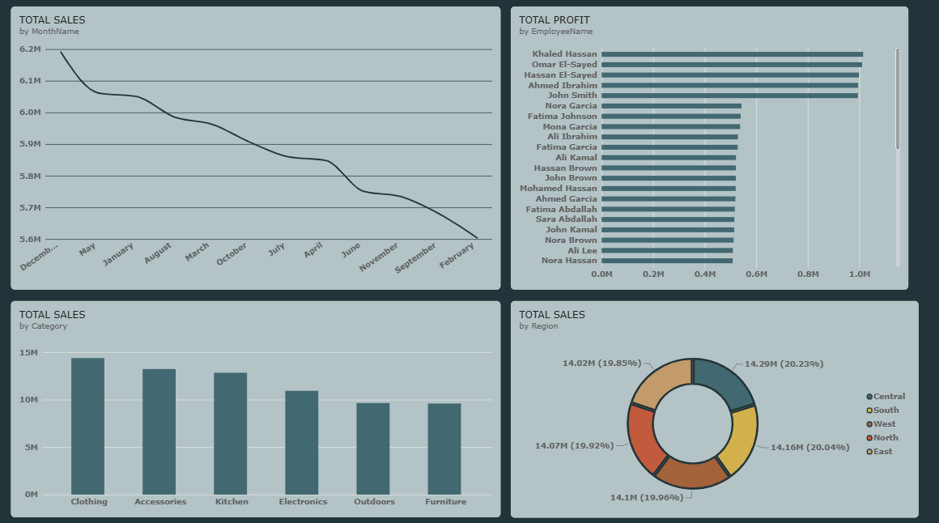

8. DASHBOARD DESIGN
The final Power BI dashboard is designed as a single-page interactive report.
The dashboard is arranged into different sections:
- The upper section contains the main KPI cards.
- The middle section contains category-wise and month-wise sales analysis.
- The lower section presents employee profit and regional sales analysis.
- The right side contains slicers and the product-level table.
This arrangement allows users to obtain a quick summary of business performance while also providing access to detailed information.
The interactive filters allow users to focus on specific years, product categories and regions, making the analysis more flexible.

  - Figure 4: Final interactive dashboard with KPI cards, charts, slicers and product-level details.

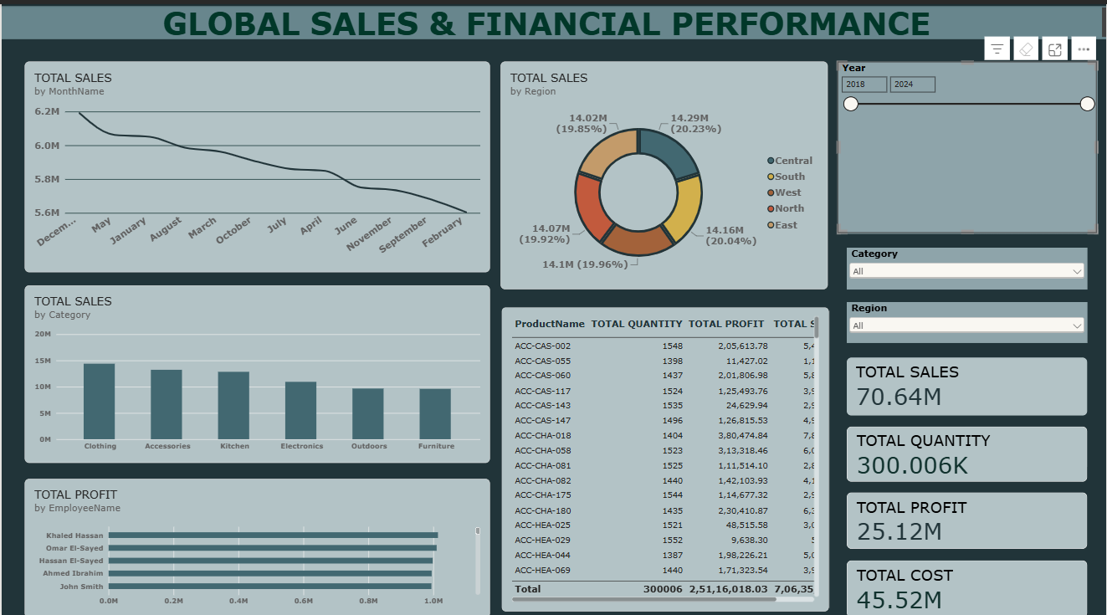
9. SLICERS
Slicers are included in the dashboard to allow users to interactively filter the report.
A. YEAR
The Year slicer allows users to select a particular year or a range of years and analyse the corresponding sales and financial performance.
B. PRODUCT CATEGORY
The Product Category slicer allows users to focus on a particular category and examine its sales, profit and quantity.
C. REGION
The Region slicer allows users to select a specific geographical region and analyse its sales and product performance.
When a slicer is selected, the connected charts, KPI cards and tables automatically update according to the selected filter.
10. KEY FINDINGS
The major findings obtained from the dashboard are as follows:
- The dashboard records approximately 70.64M in total sales.
- The total cost is approximately 45.52M, while total profit is approximately 25.12M.
- The total quantity sold is approximately 300K.
- The order count is approximately 100K.
- Clothing is the highest-selling category in the displayed category analysis.
- Employee-wise profit contribution differs across employees, with some employees reaching close to the 1M profit level.
- Monthly sales vary approximately between 5.6M and 6.2M in the displayed analysis.
- The product-level table allows individual products to be compared based on sales, profit and quantity.
- Regional sales are distributed relatively evenly across the five regions shown in the dashboard.
- The slicers provide an interactive method of analysing the report based on year, product category and region.
11. CONCLUSION
The Global Sales and Financial Performance Dashboard demonstrates how Microsoft Power BI can transform raw sales data into an interactive and informative business intelligence report.
The dashboard combines KPI cards, charts, tables, slicers and DAX measures to provide both an overall summary and detailed analysis of business performance. Sales can be examined according to product category, month, region, employee and individual product.
The use of DAX measures helps calculate important indicators such as total sales, total cost, total profit, quantity and average sales. The interactive slicers further improve the usefulness of the report by allowing users to focus on specific years, categories and regions.
Overall, the dashboard provides a structured framework for monitoring sales performance, analysing profitability and supporting data-driven business analysis.
12. REFERENCES
- Microsoft Power BI Desktop – used for data preparation, modelling, DAX calculations and dashboard development.
- Power BI Sales Data Model – comprising DimCustomer, DimDate, DimEmployee, DimGeography, DimProduct and FactSales tables.
- DAX (Data Analysis Expressions) – used for creating measures and performing calculations within the Power BI report.

